EXPERIMENT 5

5.1 PROGRAMS:
5.1.1 //Leap Year Checker
Ans : ALGORITHM:
Step 1 : Start
Step 2 : Input year y
Step 3 : Check if y % 4 == 0
Step 4 : If yes
Print "Leap year"
Step 5 : Else
Print "Not a leap year"
Step 6 : Stop

FLOWCHART:
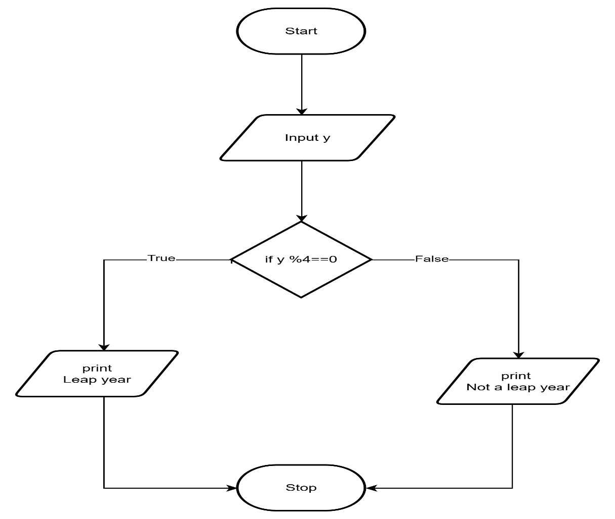
CODETANTRA:
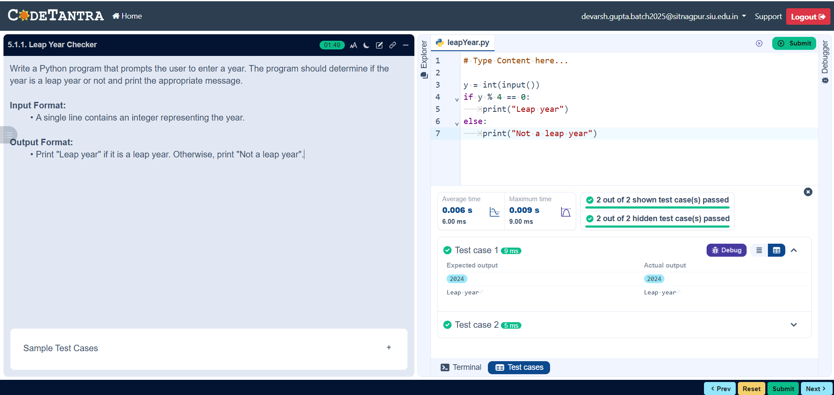

5.1.2 //Student Grade Marks Based on Aggregate
Ans: ALOGORITHM
Step 1: Start
Step 2: Input four marks: a, b, c, d
Step 3: Compute total
total = a + b + c + d
Step 4: Compute percentage
percent = (total / 400) × 100
Step 5: Print total
Step 6: Print percent (up to 2 decimal places)
Step 7: Check conditions:
- If percent > 75
Print Distinction
- Else if percent ≥ 60
Print First Division
- Else if percent ≥ 50
Print Second Division
- Else if percent ≥ 40
Print Third Division
- Else
Print Fail
Step 8: Stop

FLOWCHART:
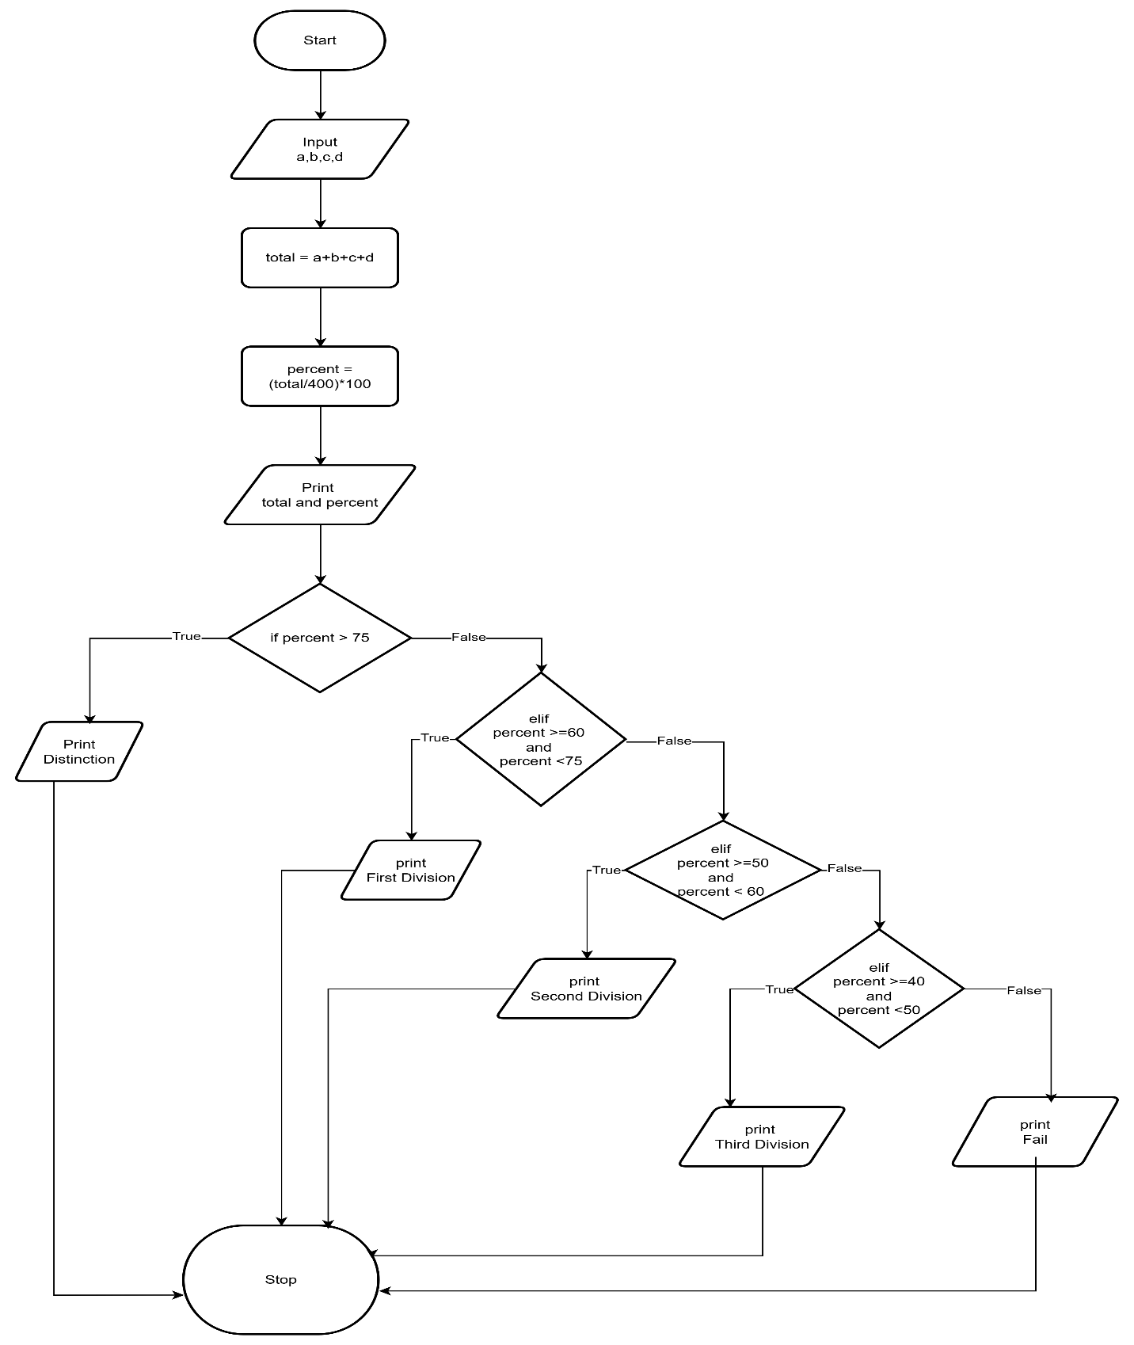
CODETANTRA:
